37. Create a JSP program to count the number of clients viewed on your website.
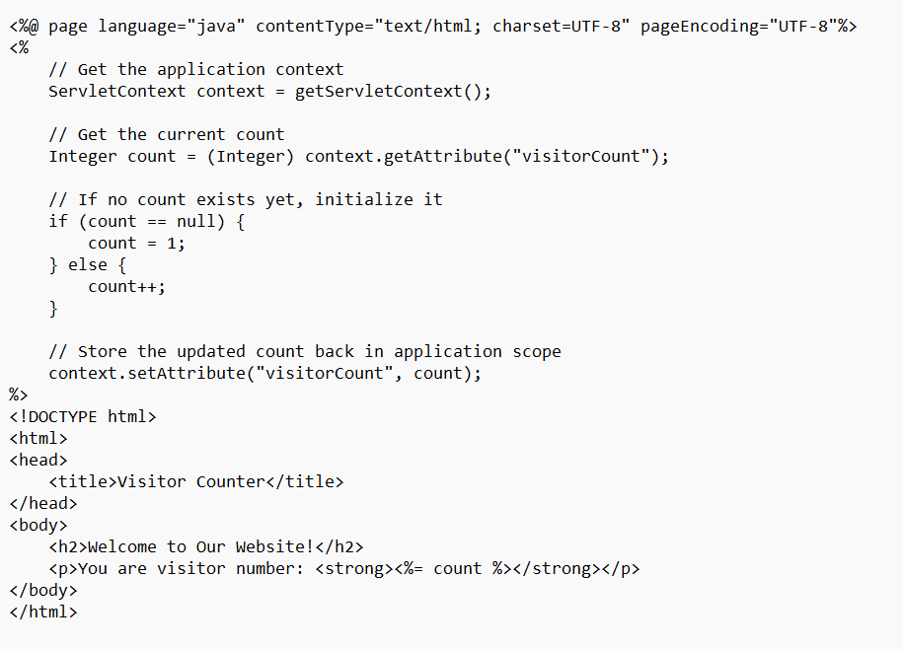output
